KENNETH L. CAMPBELL

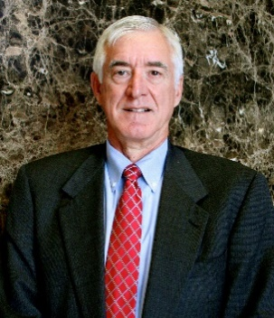

P.O. Box 60600
Nashville, TN 37206
E-mail: kcampbell@law-realtysolutions.com
Phone: (615) 330-5130
Website: www.law-realtysolutions.com

Ken is a partner in Campbell Law Solutions. A native of Oak Ridge, Tennessee, he attended Vanderbilt University on a basketball scholarship and received a B.A. in 1968. After college, he was a math teacher and basketball coach for two years at Townsend High School in Blount County. He received a J.D. from Vanderbilt University School of Law in 1972.

He received a M.B.A. from Belmont University in 1990 and then served for ten years as an adjunct professor of business law in the M.B.A. program.

Ken has been engaged in the practice of law for 47 years. In his practice, he primarily assists businesses and their owners with business, lending, real estate, taxation and estate planning issues. He represents banks and mortgage lenders in real estate and commercial lending matters. His lending clients include Pinnacle Bank in Nashville.

His real estate development practice included representation of a real estate investment entity that partnered with Hines Interests, one of the world’s leading developers, in a 12-year transformation of 1,050 acres of Williamson County farmland into Cool Springs, one of the premier mixed-use developments in the Southeast, containing 1,200 apartment units, 575 homes, 2.3 million square feet of retail space and 3 million square feet of office space. He dealt regularly with city planning commissions; utility districts; surveyors; engineers; title companies; lenders; contractors; real estate brokers; and attorneys across the country for buyers and their lenders.

He currently is local counsel for Discovery Land Company, the premier developer of golf course communities in North America, for its Troubadour development in Williamson County, Tennessee. He is also assisting a group of community leaders in Cookeville with a Community Development Financial Institution that makes loans to foster development in underserved markets. He combines his real estate and taxation knowledge by assisting families with selling family farms and acquiring investment properties with like-kind exchanges. During 2018 and 2019, he has been involved in more than $50 million of these family farm transactions.

Among his other practice areas are specialized litigation, in the real estate, tax, estate and business areas. He has been a frequent speaker at seminars on real estate law, like-kind exchanges and title insurance. Ken is also a Rule 31 mediator and is president of Realty Solutions Title, Inc., a title insurance agency.

While his practice areas are diverse, a legal problem often involves more than one of them, and he brings a broad legal and business perspective to bear on that problem.

In his spare time, Ken is a nationally ranked senior tennis player. He was chief manager of a development company that converted the firm’s former offices in an historic downtown Nashville building into residential lofts. His civic activities include serving as the chair of the board of directors of the Brentwood Cool Springs Chamber of Commerce. His wife, Susie Campbell, is an insurance agent.

